________________________________________Hbase___________________________________________
Create Namespace
create_namespace'bigdata_ID'
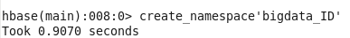

list Namespaces
list_namespace
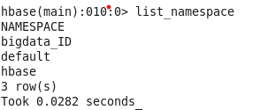

Create table
create 'bigdata_ID:Analysislog_ID','LogInfo'
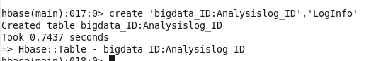

List tables
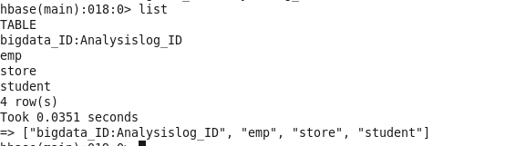

Insert the data
put 'bigdata_ID:Analysislog_ID','001','LogInfo:hostname','FI01Miner01'
put 'bigdata_ID:Analysislog_ID','001','LogInfo:service','miner'
put 'bigdata_ID:Analysislog_ID','001','LogInfo:type','info'
and so on in all data ………

scan the table
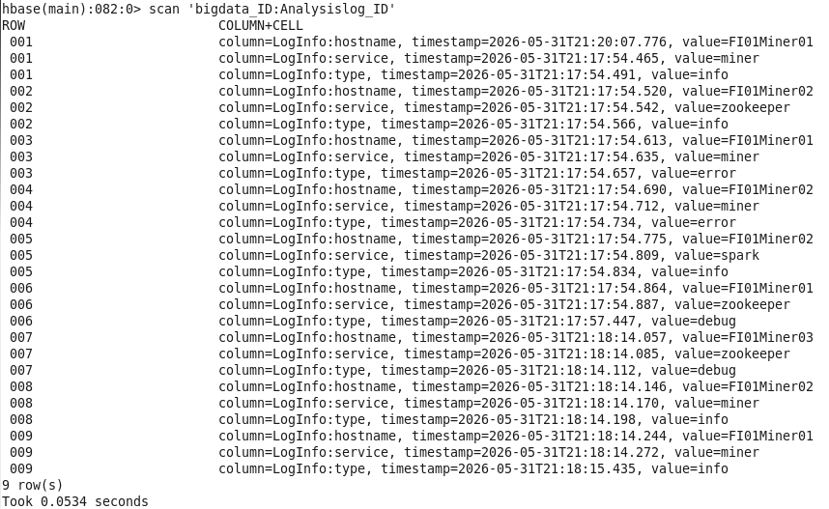

________________________________________________Hive_____________________________________________

CREATE EXTERNAL TABLE in Hive
CREATE EXTERNAL TABLE Log_hive_ID (
rowkey STRING,
hostname STRING,
service STRING,
type STRING
)
STORED BY 'org.apache.hadoop.hive.hbase.HBaseStorageHandler'
WITH SERDEPROPERTIES (
"hbase.columns.mapping"=":key,LogInfo:hostname,LogInfo:service,LogInfo:type"
)
TBLPROPERTIES (
"hbase.table.name"="bigdata_ID:Analysislog_ID"
);
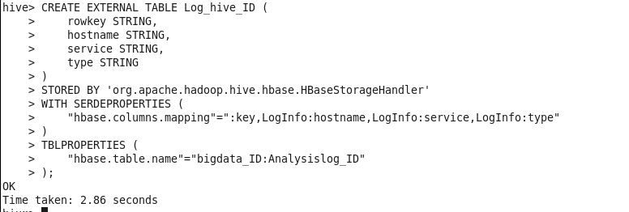

Show tables
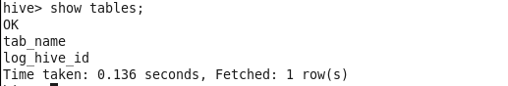
Query all log data
select * from Log_hive_id
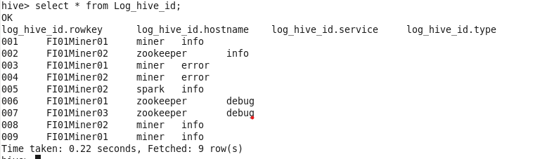

Query all log data whose service is miner using the Hive table
select * from Log_hive_id where service = 'miner';
